中高档民谣吉他FAQ
- 价格多少 Price?
答：我们中档民谣吉他价格范围在43USD - 62USD；
高档民谣吉他价格范围在43USD - 215USD
尺寸有36”/40”/41”
多种木材，颜色和桶型供选择
可提供EQ安装服务，不同价位EQ供选择
Our beginner guitar series price range from 16USD to 35USD
Different size includes 36”/40”/41”
Various wood material/colors/body shapes for your options
Custom guitar pack with accessories service available
Equalizer installation available. Different price range EQ for your options.
- 起订量多少What’s the MOQ?
- 现货 6把（根据客户情况灵活报）起订，可以混色混款
- 贴牌 120把起订，可以混款，每个型号起订量60把，每个颜色起订量３０把
注：OEM报价表首页的底价民谣MOQ是整柜，不可以混其他页面的常规款式
- Our brand stock MOQ 6PCS, mixed models/colors available
- Custom brand MOQ 120pcs, mixed models available.
Each model MOQ 60PCS. Each color MOQ 30PCS.
- 交期 Delivery Time
- 现货单3-10（根据实际情况填写）个工作日内完成
- OEM订单交期是支付定金和提供确认设计稿后的45-60天
- For available Stock order, we will send out your order within 3-10 workdays depends on the exact order list
- For OEM order, lead time is 45 to 60 days after receiving your deposit and confirmed design files.

- Package? How many pcs of guitars can be fit to a full 1x20ft/40ft Container?
常规包装的包装数据
Regular packaging package data
Size | PCS/CTN | CBM/CTN | 20GP(28CBM) | 40GP(57CBM) | 40HQ(68CBM)
36” | 6 | 0.24 | 702 | 1428 | 1698
40” | 6 | 0.25 | 672 | 1368 | 1632
41” | 6 | 0.3 | 558 | 1140 | 1362
12 string guitar | 6 | 0.35 | 480 | 978 | 1164
Acoustic bass | 4 | 0.27 | 416 | 844 | 1128
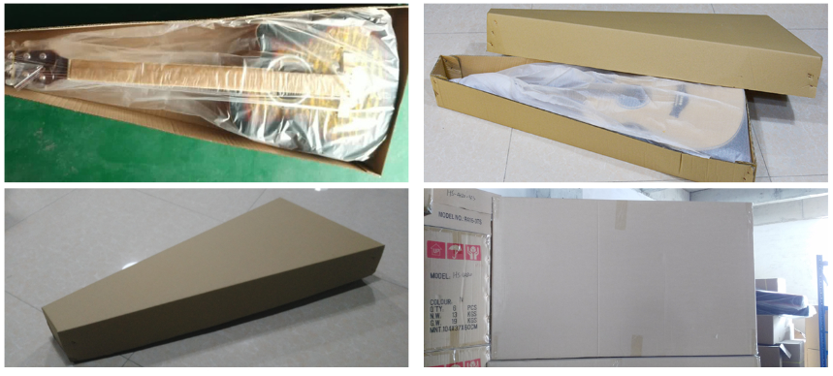
产品定制方面相关问题
- 可以定制LOGO吗？ Can i have my logo on guitar?
答：可以，最低起订量是120把， 可以混款，每个型号起订量60把
Yes, custom logo service available. MOQ 120pcs, mixed models available. Each model MOQ 60PCS. Each color MOQ 30PCS.
- LOGO位置和材质 Where i can put my logo? What’s the logo material?
答：琴头LOGO，定制内标，内盒和外箱印LOGO
- Logo on guitar head. Please send the design to confirm any extra cost
- Custom sound hole label. Please send the design to confirm any extra cost
- Logo on box and carton
琴头LOGO默认是单色水标 Single color decal logo on head
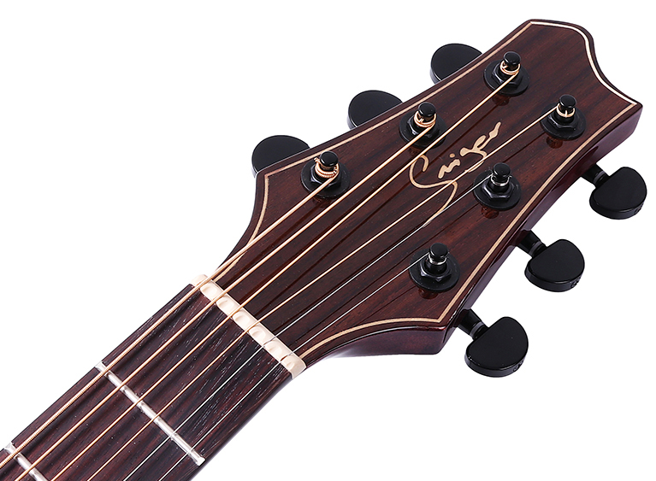
内标默认是原木色打印的纸张
Custom natural wood color printing paper label label in sound hole
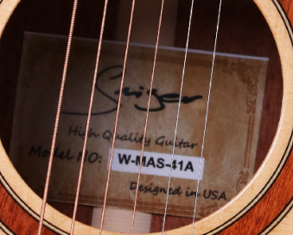
内盒黑色LOGO
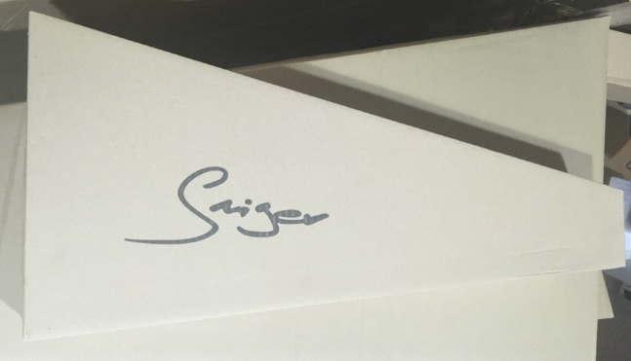
外箱黑色LOGO
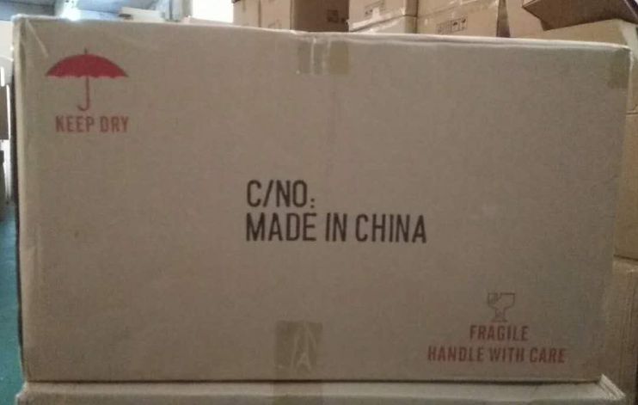

- 内标上可以做不同序号吗？ Can we custom different Serial Number inside tone hole?
Will add USD0.5/pc if custom different serial number on the tag.

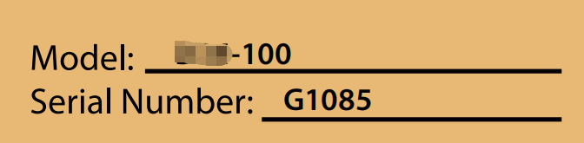
- 拾音器安装服务： Can I have ukuleles with pickup?
答： 我们能提供安装EQ的服务。请从EQ价目表里选择你需要的EQ，EQ 安装费10元/把。
We can install pickups to ukulele, please choose pickups from price list, install fee 1.67USD for each pickup.

- Custom bundle service 套装定制服务 can I order as a guitar bundle?
答：我们可提供套装定制服务，配件可包括调音器，背带，备用琴弦，拨片，背包或皮盒，变调夹等,请从价目表里选择你要的款式。我们会根据要求打包
We provide custom bundle service, please choose accessories from accessory price list, normally a bundle includes tuner, strap, bag or hard case(for high grade guitars), spare string set, capo, picks, etc. We will pack as your requirements.

- 更换配置费用
- 左手吉他+3元
Left handed + USD 0.5/PCS
- 指板 Fingerboard
玫瑰木指板换成科技木不加钱
亚克力块状音点+15元
- 包边 Binding
ABS和赛露露包边差价10元
- LOGO
白贝LOGO+12元
枫木LOGO镶嵌+5元
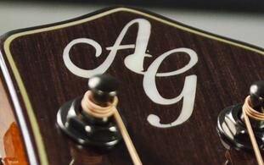
- 包装
- 邮购包装+15元/把
- 彩盒Color box
MOQ 是1000个
尺寸 | 每把增加费用
34寸 | 3.40
36寸 | 4.40
38寸 | 4.50
39寸 | 4.80
40寸 | 5.20
41寸 | 6.00

Color box MOQ is 1,000PCS， extra cost as below.
SIZE | EXTRA COST/GUITAR
34” | $0.57
36” | $0.73
38” | $0.75
39” | $0.80
40” | $0.87
41” | $1.00

- 各国偏好
国家 | 热销型号 | 尺寸 | 颜色 | 其他要求备注 | 做过的牌子
尼日利亚 | LG-09,LG-07,SM-412/3, M-4160 | 40,41寸 | N, | 装EQ，  配连接线，包
美国 | M-215-40,  MAS-41A  MES-41A,  MDS-41A,M-F1SS  SM-361/401 | 40,41寸 | N | 装EQ （高档）  内标：每个内标不同序列号  配包，高档加厚包  红松面单，指板不要镶嵌
加拿大 | SM-401-A/C  LG-07-09  EN/FN/GN | 40,41寸 | N，擦色
缅甸 | EN/FN-10/20/25/30/LG-09-EQ/ | 40寸 | N
柬埔寨 | M-210-41  M-410-41

- 客户好评截图

